# Section 1 – Installation instructions

## Step 0 – SAS software and ABS data

Users must have SAS software on their computer to use CAPITA.

The 64-bit version of Microsoft Office (as opposed to the 32-bit version) is also required for Microsoft Excel to work alongside SAS.[1]

To run CAPITA, users must also obtain access to the ABS Confidentialised Unit Record Files for the:

* 2013-14 Survey of Income and Housing (SIH); and
* 2011 Census.

The costs involved in acquiring these datasets are detailed on the ABS website.

## Step 1 – Download files and save them to your drive

Download the files from Github and save them to your drive. For the purposes of this guide we refer to the location where the files are saved as “\\CAPITAlocation\”

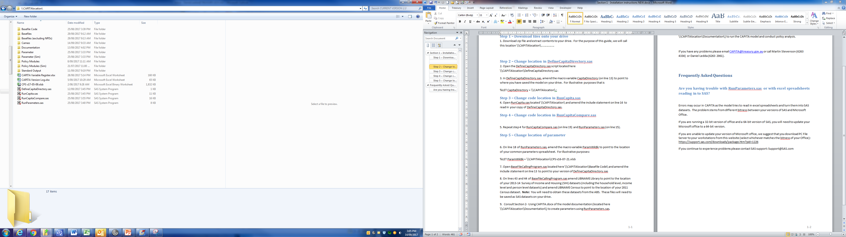

## Step 2 – Change directory in DefineCapitaDirectory.sas

Open the DefineCapitaDirectory.sas script located here: \\CAPITAlocation\DefineCapitaDirectory.sas.

Amend the macro variable CapitaDirectory to point to where you have saved the model on your drive (see figure below).

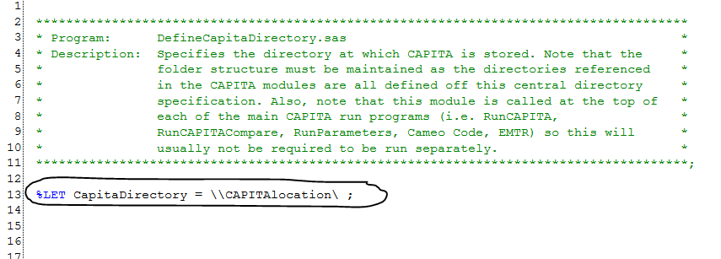

## Step 3 – Change directory in RunCapita.sas

Open RunCapita.sas located here: \\CAPITAlocation\RunCapita.sas.

Amend the include statement to read in your copy of DefineCapitaDirectory.sas.

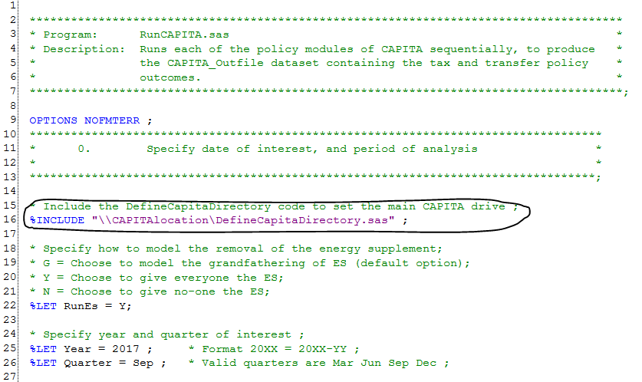

## Step 4 – Change directory in RunCapitaCompare.sas

Repeat step 3 for RunCapitaCompare.sas located here:

Located here: \\CAPITAlocation\RunCapitaCompare.sas.

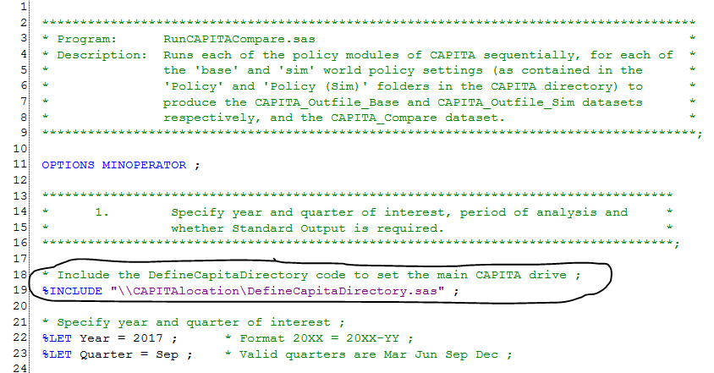

## Step 5 – Change directory in RunParameters.sas

Repeat step 3 for RunParameters.sas located here:

Located here: \\CAPITAlocation\RunParameters.sas.

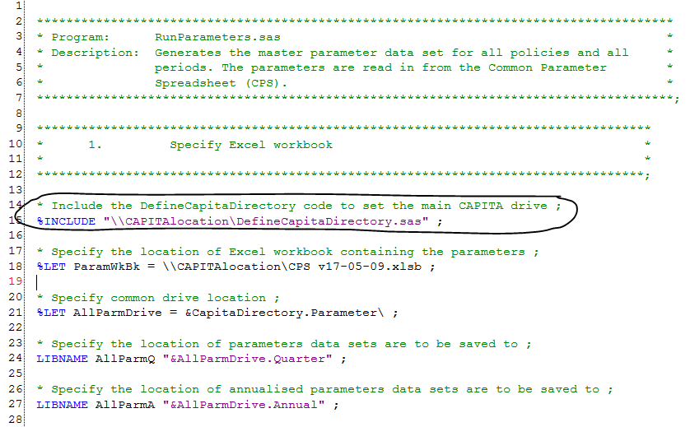

## Step 6 – Change location of parameter spreadsheet in RunParameters.sas

In the RunParameters.sas program, amend the macro variable ParamWkBk to point to the location of your common parameters spreadsheet (CPS).

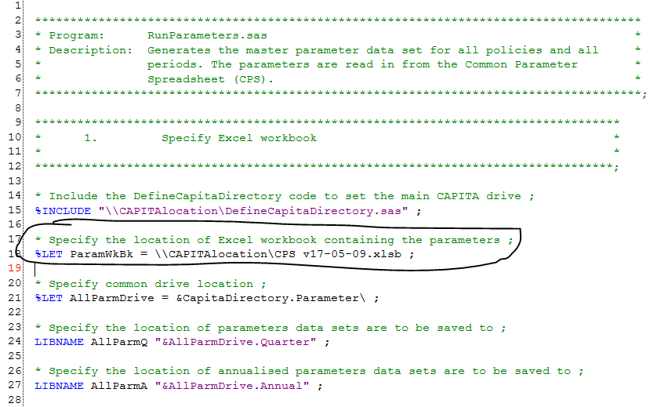

## Step 7 – Change directory in BasefileCallingProgram.sas

Repeat step 3 for BasefileCallingProgram.sas located here:

Located here: \\CAPITAlocation\Basefile Code\BasefileCallingProgram.sas.

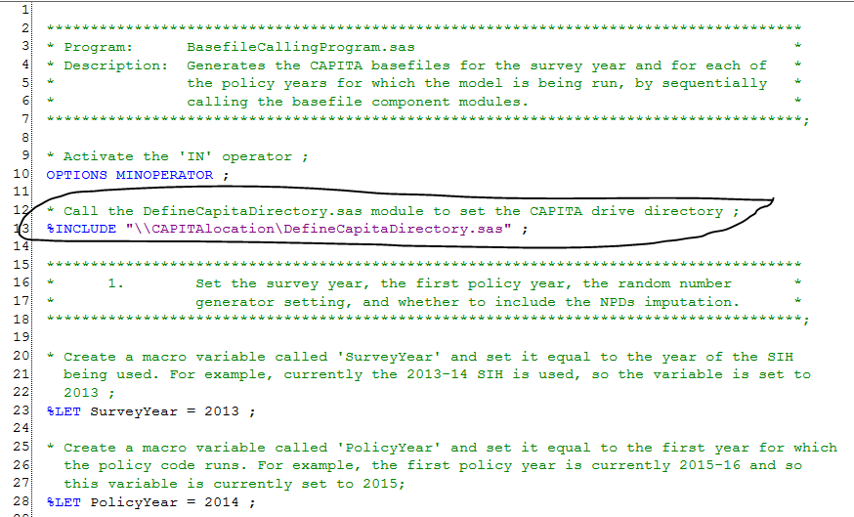

## Step 8 – Change SIH and Census directory in BasefileCallingProgram.sas

On lines 43 and 44 of BasefileCallingProgram.sas amend LIBNAME Library to point to the location of your 2013-14 Survey of Income and Housing (SIH) datasets (including the household level, income level and person level datasets) and amend LIBNAME Census to point to the location of your 2011 Census dataset. **Note:** You will need to obtain these datasets from the ABS. These files will need to be saved as SAS datasets on your drive.

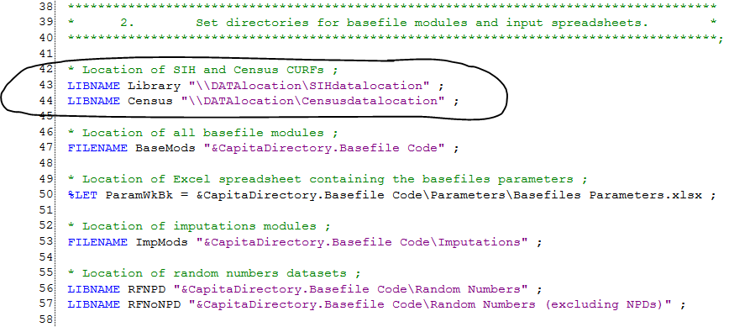

## Step 9 – Create parameters using RunParameters.sas

Consult Section 3 – Using CAPITA.docx of the model documentation (located here \\CAPITAlocation\Documentation\) to create parameters using RunParameters.sas.

## Step 10 – Create basefiles using BasefileCallingProgram.sas

Consult Section 4 – Guide to CAPITA Basefiles.docx of the model documentation (located here \\CAPITAlocation\Documentation\) to run the basefiles code.

## Step 11 – The model is ready to use

Consult Section 3- Using CAPITA.docx of the model documentation (located here \\CAPITAlocation\Documentation\) to run the CAPITA model and conduct policy analysis.

## Feedback

To provide feedback or if you have any installation issues please email [CAPITA@treasury.gov.au](mailto:CAPITA@treasury.gov.au) or call Martin Stevenson (6263 4334) or Daniel Ledda (6263 2061). Please also email if you are using the model and are interested in attending user group meetings.

1. If you are unable to update your version of Microsoft office, we suggest that you download PC File Server to your workstations from this website (select whichever matches the bitness of your Office): <https://support.sas.com/downloads/package.htm?pid=1226>

   If you continue to experience problems please contact SAS support: Support@SAS.com